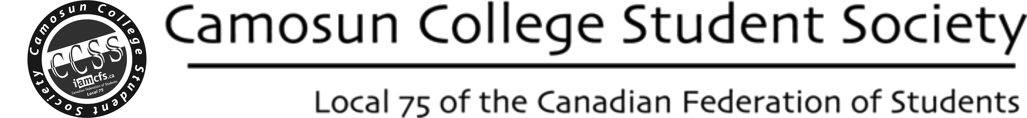

CCSS SERVICE REQUEST FORM

This form allows registered student groups to request service from the CCSS. These service include:
poster and banner printing, support for campus activities, email and web service, t-shirt printing and bulk materials ordering, coffee and tents for outdoor activities, etc.

Name: Email: Phone:

Group Name: Today's Date:

Description of the request:
Additional information about planned activities (dates, locations, purpose, etc.):
Number of students participating in your group: OPTIONAL: Weeks until activity:

Please note that not all requests can be fulfilled. Someone will respond to your request within 2 weeks. If you have any questions, please contact us by email: clubs@camosunstudent.org

This form can be submitted at: http://CamosunStudent.org/clubs/forms/submit

